How to create a SOTF event on the website:
- Log in. Click on "Events" and "Create or Manage Event". Click on the red button on the right-hand side that says "Add New".
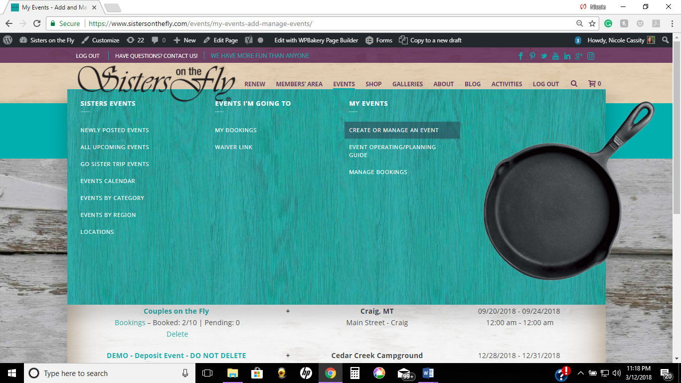
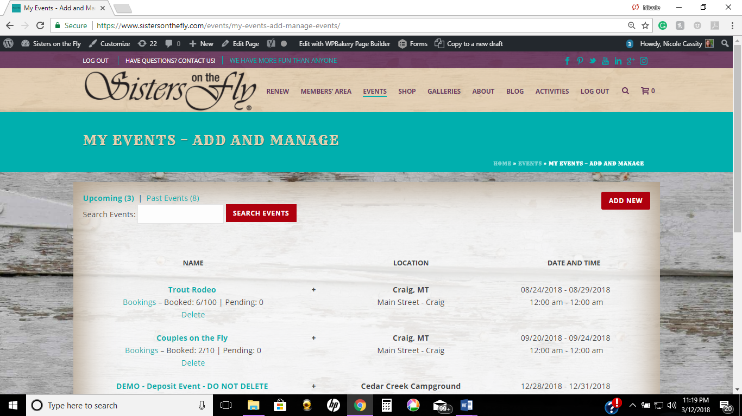

- Enter event name and City and State of the event location, i.e., Sisters at the Springs, Challis, ID.
- Check the “recurring event” box If the item will regularly recur, i.e, monthly luncheon, meet and greet.
- Enter date and location.
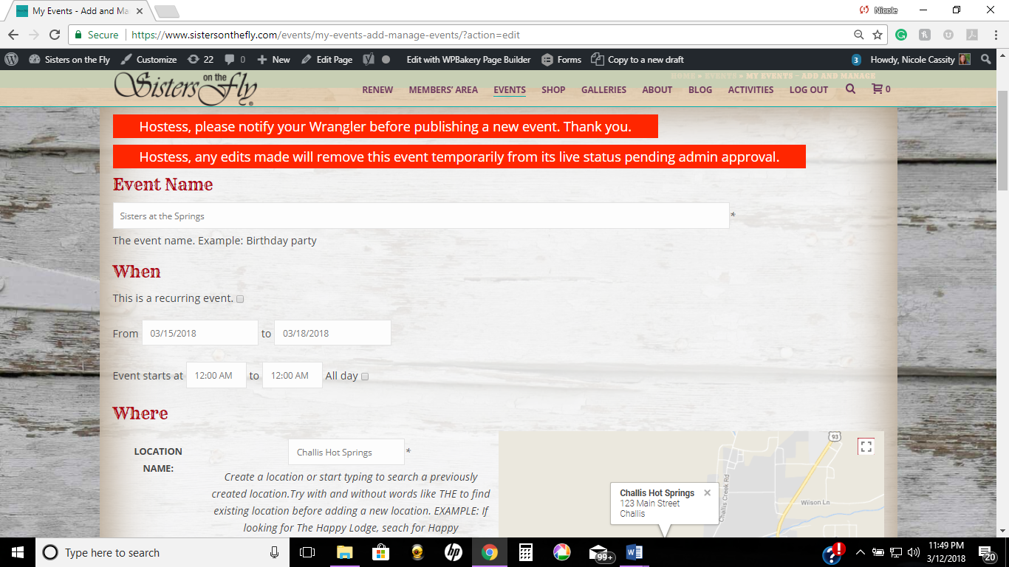
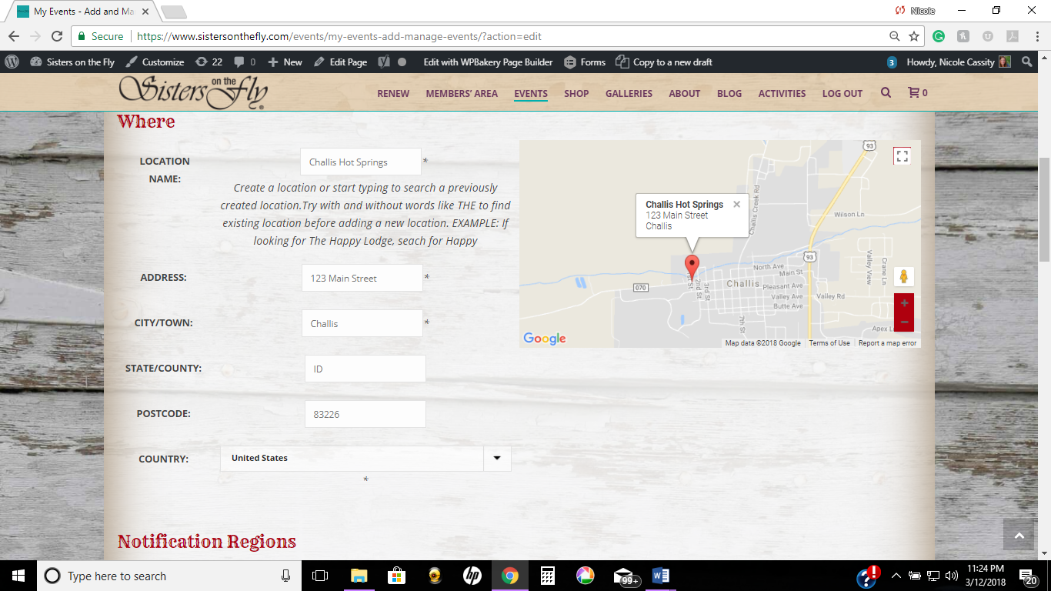

- Complete “Notification Regions” indicating the region in which the event is taking place. If a Regional Event, check “All” to notify Sisters in all regions.
- To send email to the Sisters about the event, check “Notify Sisters.”
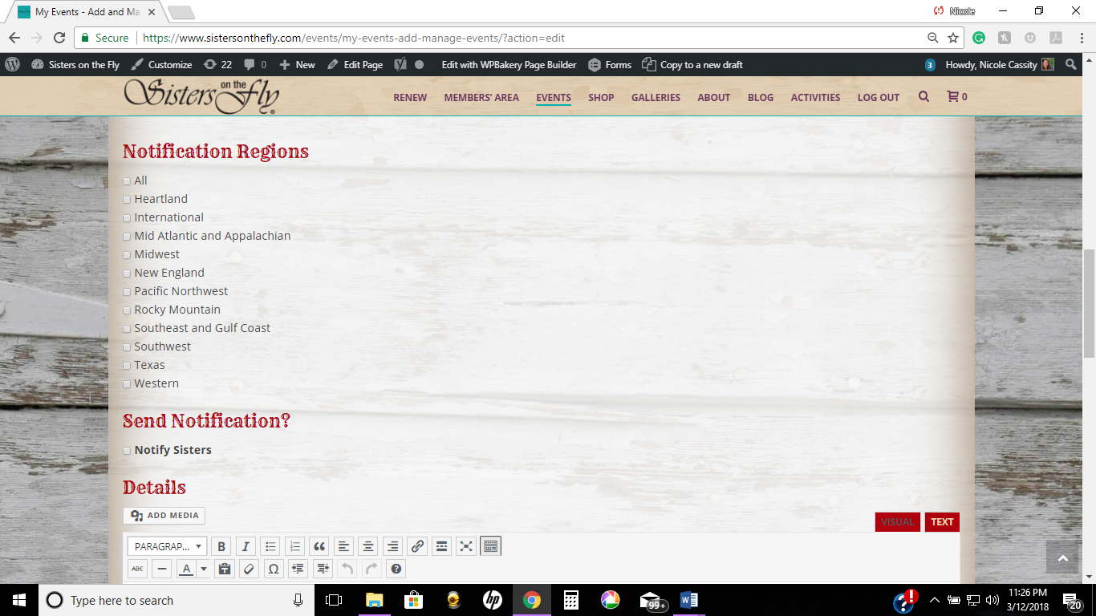

- “Details” section should be as specific as possible. Include the items contained in the definition section of the Event Planning Guide under Details such as the following:
- Hostess/Co-hostess names, numbers contact information
- General description/Specific Itinerary to include: a) accommodations, facilities/sanitation/infrastructure/type of camping; b) weather, area history, geology, activities, etc.; c) Fees/payment methods/refund policy/optional add-ons; d) food;e) special activities (craft/costume/supplies/conditions/deadlines); f) Waitlist policy.
- The following illustrate examples of three different event types Details.

If this was a No Fee Event your “Details” section would look like this:
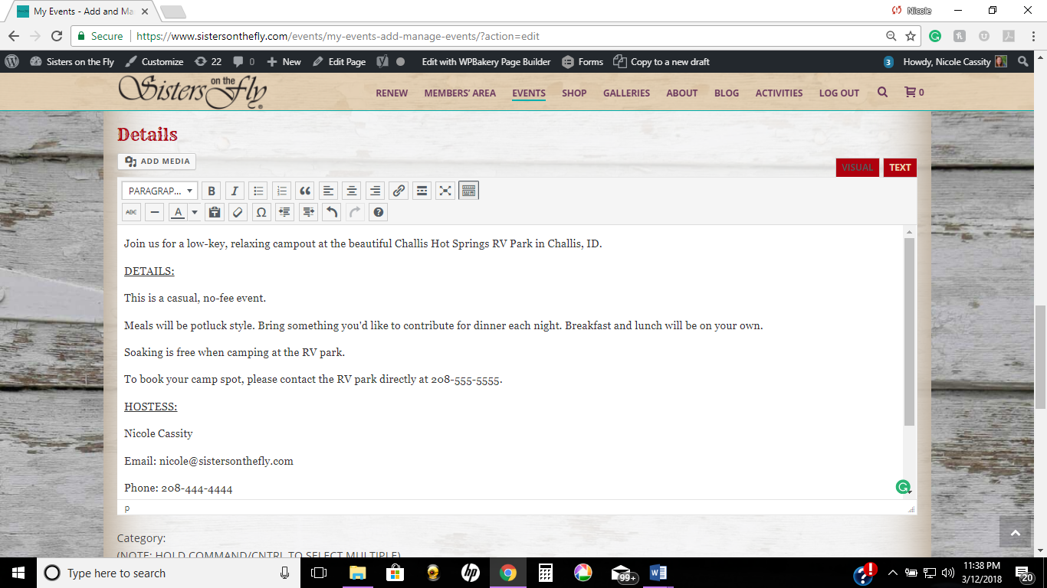
If this was an Independent Fee_Based Event, your “Details” section would look like this:
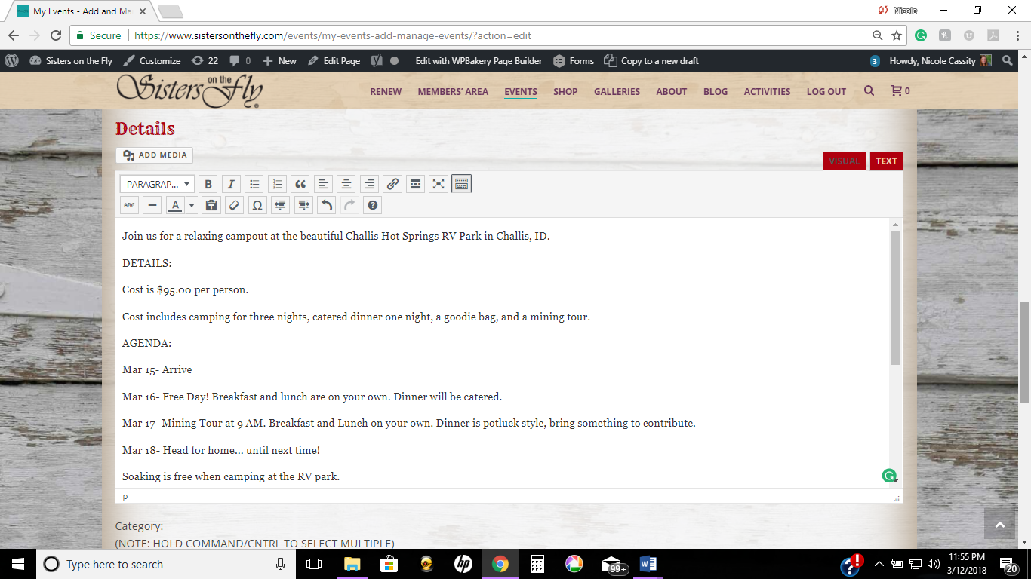
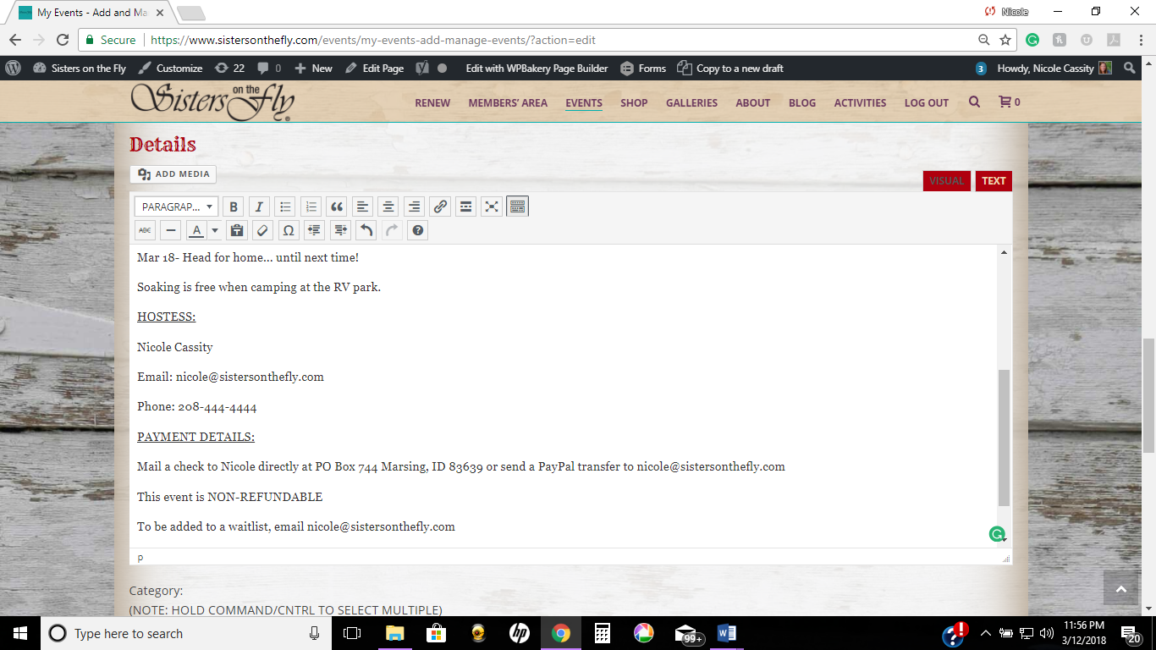

- Indicate the “Category” that applies such as Rocky Mountain Region, Montana, Cowgirling, etc.; if multiple categories apply, hold down the control (or command) button and select as many as apply.
- Add a photo for the event at “Event Image” .
- Bookings/Registrations: Check “Enable registration for this event” to open ticket options.
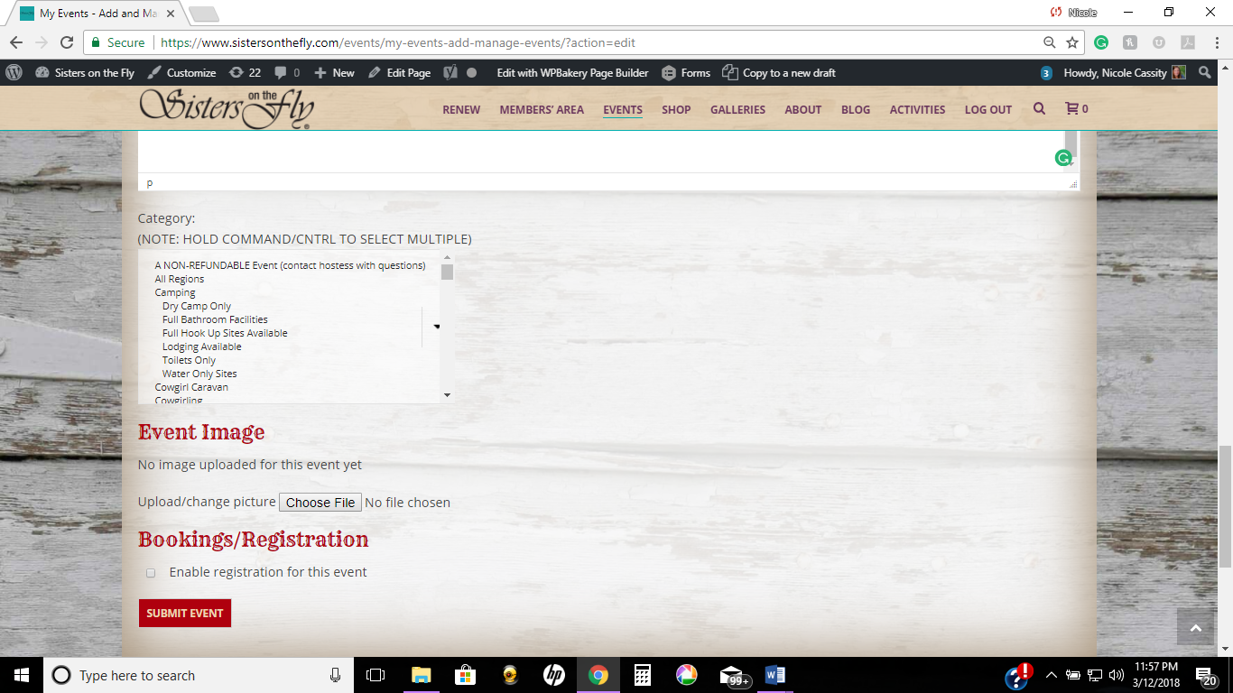
- Indicate “Ticket Options.”
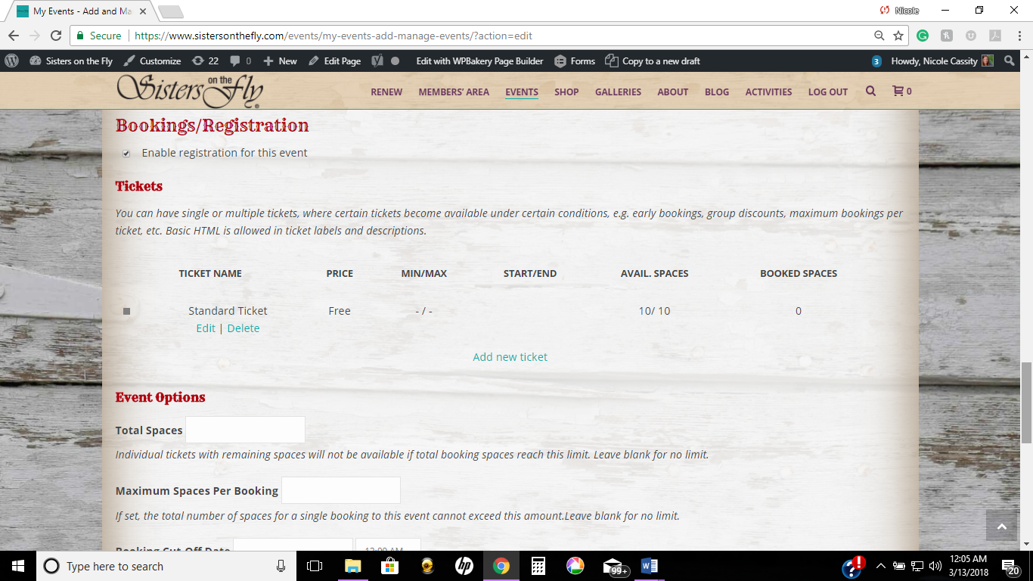

For NO Fee Event or Independently Hosted Event, change ticket name to whatever you’d like, edit the spaces available and change the ticket price to $0.00 by clicking “edit” below “Standard Ticket”. These two event options will always have a ticket price of $0.00 because the hostess will be collecting the funds directly and this feature will instead act as an RSVP.
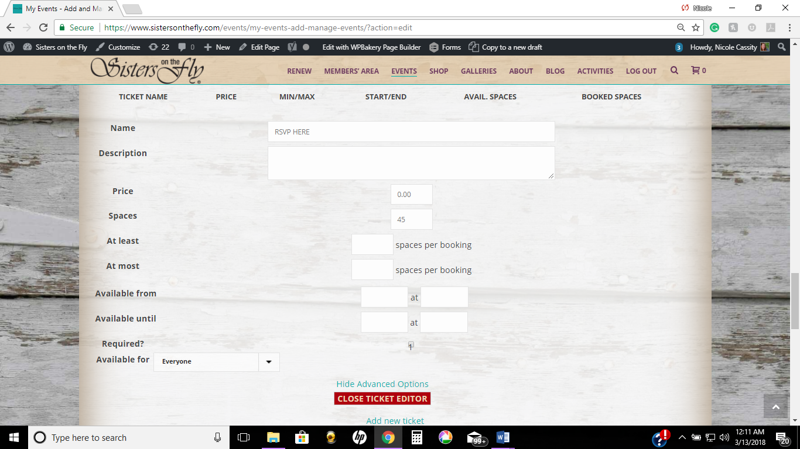
- Important- Indicate the number of available spaces (maximum number of attendees) in the “Spaces” field. All of the other fields are optional.
- Important- Click on red "Close Ticket Editor" button at the bottom of the section or the data will not be saved.
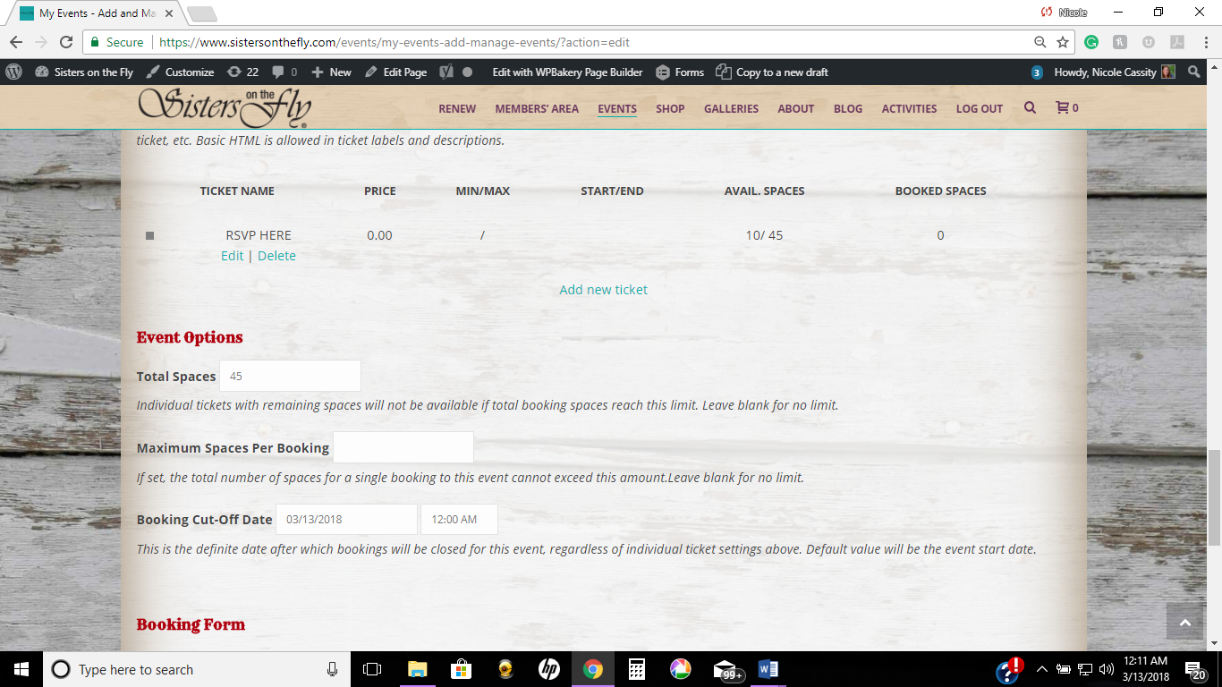

- Click “Submit Event”.

- Tickets may be created for multiple payments. For example: Deposit, Final Payment, Wine Tour add-on, T-Shirt, Horseback Riding add-on, etc.

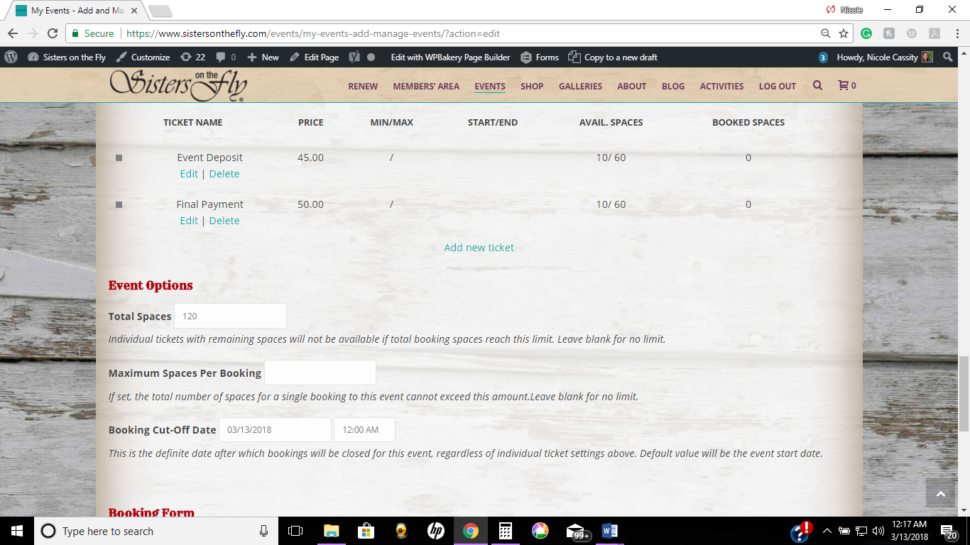

- Event Options- This is where you will repeat the amount of spaces available above in the ticket options field. For “Total Spaces”, add together the maximum available spaces for each ticket type. In the example above, it is 60 Deposit tickets and 60 Final Payment tickets = 120 total spaces.

- Leave “booking form” to “default”

- Click “Submit Event”.

Missing fields will appear in RED at the top of the screen must be updated. Click “submit event” again and if your event goes through correctly, you will be directed to your personal event page and it will say “You have successfully submitted your event, which will be published pending approval.”

You will receive an email letting you know your event has been approved. You will also receive an email each time someone registers for your event.

You can view your event details and a detailed list of who has booked by clicking on the “Events” tab, then “create or manage an event”. To view and edit your event information, click on the event name. To view your bookings, click on “bookings” found below the event name.

