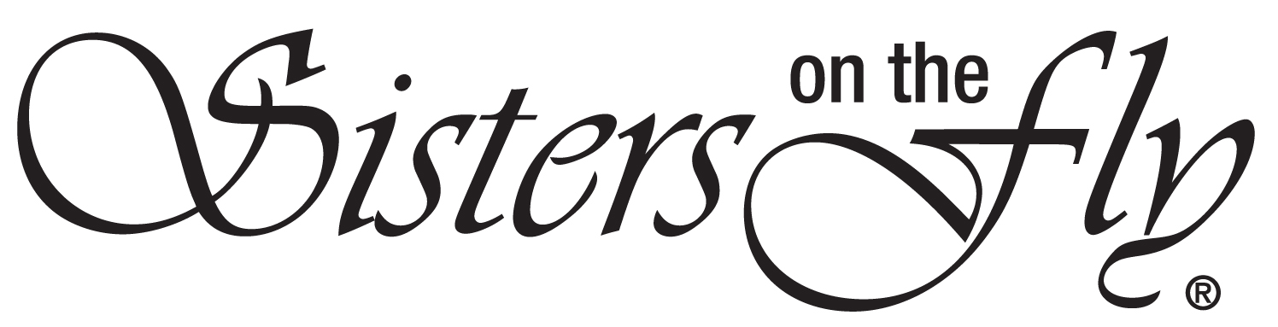
WELCOMES YOU!
MEMBER and WAIVER OF LIABILITY AGREEMENT
**Everyone attending a SOTF Activity must complete and sign!**
I, the undersigned, acknowledge that I am voluntarily participating in this Sisters on the Fly Activity.
I HEREBY ASSUME ALL OF THE RISKS OF PARTICIPATING AND/OR VOLUNTEERING IN THIS ACTIVITY, including but not limited to, any risks that may arise from negligence or carelessness on the part of the persons or entities being released, from dangerous or defective equipment or property owned, maintained, or controlled by them, or because of their possible liability without fault.
I certify that I am physically fit, have sufficiently prepared or trained for participation in the activity, and have not been advised not to participate by a qualified medical professional; there are no health-related reasons or problems which preclude my participation in this activity. I agree that my safety is primarily my responsibility. I agree to make sure that I know how to safely participate in the activity safely, and I agree to observe any rules and practices that may be employed to minimize the risk of injury. I agree to stop and seek assistance if I do not believe I can safely continue, to limit my participation to reflect my personal fitness level, and to refrain from any and all actions that would pose a hazard to myself or others.
I acknowledge that this Accident Waiver and Release of Liability Form is between myself and Sisters on the Fly and it will govern my actions and responsibilities at said activity.
In consideration of my registration and permission, as a member in good standing of Sisters on the Fly I hereby take action for myself, my executors, administrators, heirs, next of kin, successors, and assigns as follows:
(A) I WAIVE, RELEASE, AND DISCHARGE from any and all liability, including but not limited to, liability arising from the negligence or fault of the Sisters on the fly or its affiliates, wranglers, hostesses, for my death, disability, personal injury, property damage, property theft, monetary loss or actions of any kind which may hereafter occur to me including my traveling to and from this activity,
(B) I INDEMNIFY, HOLD HARMLESS, AND PROMISE NOT TO SUE Sisters on the fly from
any and all liabilities or claims made as a result of participation in this activity,
whether caused by the negligence of Sisters on the Fly or parties purported to be acting on their behalf or otherwise.
I acknowledge that Sisters on the Fly, its directors, officers, volunteers, representatives, and agents are NOT responsible for the errors, omissions, acts, or failures to act of any party or entity conducting a specific activity on behalf of Sisters on the Fly I acknowledge that this activity may involve risks and may carry with it the potential for death, serious injury, property or monetary loss. The risks may include, but are not limited to, those caused by terrain, facilities, temperature, weather, condition of participants, equipment, vehicular traffic, actions of other people including, but not limited to, participants, volunteers, and activity officials.
I hereby consent to receive medical treatment which may be deemed advisable in the activity of injury, accident, and/or illness during this activity.
I understand that at this activity or related activities, I may be photographed. I agree to allow my photo, video, or film to be used for legitimate purposes by Sisters on the Fly or its assigns.
For International events, I understand that all or most insurance coverage that I currently have may not cover me, or my assets in a foreign country. It is my responsibility to understand my insurance coverage and purchase additional coverage if I choose.
The accident waiver and release of liability shall be construed broadly to provide a release and waiver to the maximum extent permissible under applicable law.
I understand that Sisters on the Fly makes no guarantee or warranty as to the actual execution of events and event related activities and agree to hold Sisters on the Fly harmless for any failure in meeting my expectations and that Sisters on the Fly is not responsible for funds collected by Independent Hostesses and not responsible for any refunds.
I have read and agreed to the Attendee Agreement.
I have read the Pet Event Policy and with comply with all provisions of the policy when attending dog friendly events with my dog.

I CERTIFY THAT I HAVE READ THIS DOCUMENT, AND I FULLY UNDERSTAND ITS CONTENTS. I AM AWARE THAT THIS IS A RELEASE OF LIABILITY AND A CONTRACT AND I SIGN IT OF MY OWN FREE WILL.

_______________________________________
Name, Sister Number

